At a Glimpse

Name of Company: REVERSE DESIGN LTD.
Nature of Business: Merchandise and Quality Management Services
Corporate Office: Level-01, House-01, Road-22, Sector-10, Uttara, Dhaka-1230, Bangladesh

Website: https://reverse-design.net
Phone: (+88) 01715-090515
Email: info@reverse-design.net

Executive Body

Managing Director: M. Aladin Alim
Email: aladin@reverse-design.net
Director: AKM Saiful Azam Sultan
Email: saiful@reverse-design.net
Director: Md. Kamrul Islam
Email: kamrul@reverse-design.net

Sister Concern

Name of Company: THE ALADIN APPARELS
Nature of Business: Sweater Manufacturing Unit
Corporate Office: Level-01, House-78, Block-D, Noyanichala Central Masjid Road
(Near Prottasha Bridge), Turag, Dhaka-1230.
Factory Address: Matabbar Bari, Chandora, Gasa, Gazipur, Bangladesh
Contact Person: M. Aladin Alim, CEO
(+88) 01715-247347
ceo@aladin.net.bd
https://aladin.net.bd
TIN: 214948514406
BIN: 0063212680102
ERC: 260326210930024
REX: BDREX04116

Bank Management:

Lien Bank Details: THE ALADIN APPARELS

Islami Bank Bangladesh PLC
Farmgate Branch
Malek Tower, 31Tejkunipara, Tejgaon, Dhaka-1215
Account no: 20501360100571414
Swift: IBBLBDDH136,
Routing number: 125261458
Mail: farmgate@islamibankbd.com
Phone: +88028115103‬‬‬‬‬‬‬

Agrani Bank Limited
Uttara Model Town Corporate Branch
House-09, Road-12, Sector-6, Uttara, Dhaka-1230, Bangladesh.
Account no: 0200022873109
Swift: AGBKBDDH045
Routing number: 010264694
Mail: uttarabr@agranibank.org
Phone: +88028933248‬‬‬‬‬‬‬

Al Arafah Islami Bank PLC
Uttara Model Town Branch
House-01, Road-13, Sector-4, Uttara, Dhaka-1230, Bangladesh.
Account no: 0171020077895
Swift: ALARBDDH082
Routing number: 015264699
Mail: mgr.uttara@aibl.com.bd
opmgr.uttara@aibl.com.bd
Phone: +8802224470978‬‬‬‬‬‬‬

About Us

REVERSE DESIGN LTD. is dedicated and passionate about the design, production and manufacture of world class apparels and garments utilizing the latest trends, technologies and processes.

In order to achieve our ambitious vision to become a world-class garment manufacturing corporation, REVERSE DESIGN LTD. not only focuses on qualitative management and environmental control but also active maintenance of proper inter-relationship with our personnel and all the neighboring communities.

Being under current global economic landscape characterized by volatility and recession, especially among our major export markets such as the United States and the European Union, cost reduction initiatives are an approach to maintain our competitiveness in an ever-changing global marketplace. Concurrently, we aim to shorten our delivery period to even better respond to our customer needs.

The secret of the Company’s success thus far can be credited to the key connections and relationships the business has maintained driving customer trust and loyalty.

I invite you to explore the potential of REVERSE DESIGN LTD. in helping to supply and deliver world-class finished apparel and garment solutions for everyone from infants, boys and girls, to adult men and women; across a range of essentials, smart, casual, formal and sporting applications.

Thanking You,
REVERSE DESIGN LTD.

Message

We are pleased to inform you that REVERSE DESIGN LTD. is a promising sourcing house in Bangladesh. We have strong merchandising and quality team to run everything from sampling to shipment. We specialize in any kind of knit, woven and sweater, because we have our own 100% export-oriented factory, especially knit and sweater.

We also supply woven items such as Denim, Twill, Fake Down, Padding Jackets, Headwear (Caps), Leather, Jute and Handicrafts from the sourcing factory. As a result, we are able to support fast sampling, full quality production, timely shipments as well as attractive prices.

We have been steadily doing business in this sector for decades. Our main markets are, USA, Canada, Finland, Spain & France respectively. We are already enhancing the market in Australia, Portugal, Netherlands & Russia as well. In addition, we want to more perform all over the world since our return of client values are well efficiency.

Thanking You,
Team
REVERSE DESIGN LTD.

Overview

Our management team comprises professionals who have been in the industry for more than 15 years with their vast and varied experience, we are able to identity the needs of our business partners and accommodate them expertly. With more than 4000 employees in our group, which includes a team of Managers, Compliance officer, Merchandisers and Quality Controllers, we provide dedicated & personalized services. We continue to employ experienced and fresh potentials to complement and enhance our services to our client.

From our own production house and from 25 lease-based factories currently we have an annual production capacity; 8 million units in Knit // 5 million units in Sweater // 6 million units in Woven respectively. We specialize from product conceptualization to production to delivery for both apparels and Accessories industry. Our knowledge on USA, European and Asian markets give us distinctive advantage over our competitors. In the year 2019 we have achieved a turnover of USD $50 million.

Who We Are

REVERSE DESIGN is one of the leading sourcing houses with a vast experience over the last decade in the readymade fashion garments sector. REVERSE DESIGN has been started working in the RMG (Readymade Garments) all over the world with a vested focus on the USA, Canada, Germany, Spain, France and Italy. Based in Dhaka, Bangladesh and having liaison offices in both UAE, Canada and Finland we aim to tailor the work plan accordingly. Besides RMG items REVERSE DESIGN has significant experiences in supplying Surgical Items, Fabrics, Headwear (Caps), Home Textiles, Leather Goods, Handicrafts are such as well.

Why Choose Us

To achieve the best quality at a reasonable price tag, if that is the purpose you are looking for then you are at the right place. We offer solution services and consultancy to accelerate your business needs and put your venture in a growth trajectory. Just drop the queries you have. Also, 10 Nos Merchandisers with 20 Nos QA team are soundly managed to our respective customers smoothly.

Manufacturing Partners
Fariha Knit Tex Ltd. Gallery Tex Ltd.
Tex Zone Ltd. Green Life Knit Composite Ltd.
Alps Apparels Ltd. Fashion.com Ltd.
Shad Fashion Ltd. JS Knitting & Garments Ltd.
Sunman Group The Aladin Apparels
Din Sweaters Ltd. Deco Crafts Ltd.
Supply Chain

Fashion Design:

We complement our client’s design department. We create styling according to the client’s specifications on fabrics, garments & accessories. We research on consumer demands and future trends. Using latest technology, we keep abreast of the developments in the fashion industry and initiate trendy products

Product Development & Planning:

With our well-established relationships with the factories including some of our own factories, we are able to get samples at the right quantity at the right time. We ensure that samples are made according to the client’s specifications. We also re-create and modify popular styling to suit our clients demands. Together with our experienced staffs, we plan and organize the entire production process systematically. Every step of the process carefully planned and recorded. We monitor daily & weekly output to ensure timely delivery.

Quality Assurance:

We ensure that factories production according to our client’s requirements and specifications. Our team of quality controllers conduct regular checks to assure quality is maintained at all times. Our QCs specialize in raw materials to finished goods inspection. They are also equipped with knowledge to give technical assistance to the manufacturers and high-end tools to conduct precise checks.

Logistics & Export:

We take care of all the necessary shipping arrangements and ensure all documentary procedures are made accordingly so that all shipments reach our clients promptly. Sourcing Our strong team of researcher’s source and evaluate the mills & accessories manufacturers on the field. With our strong global network, we only seek yarn, fabric & accessories of the best quality & competitive price for our clients.

Factory Strength & Supervision:

We have a network of more than 80 factories in Bangladesh. The factories specialize in all types of apparels. Our evaluation team and quality controllers always ensure that all the factories are well-equipped and qualified. We believe that the only way to ensure quality and timely delivery is to monitor an order from its inception. We follow through the order from fabric production and dyeing to delivery to the production line.

Products Category
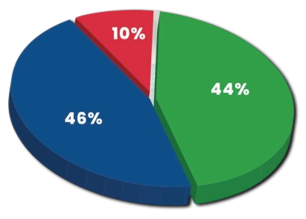
- Circular Knit
- Flat Knit
- Woven Item

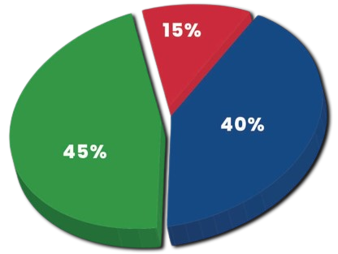
- Ladies
- Men’s
- Children

We specialized in all verities in Garments
Global Operations & Business Growth
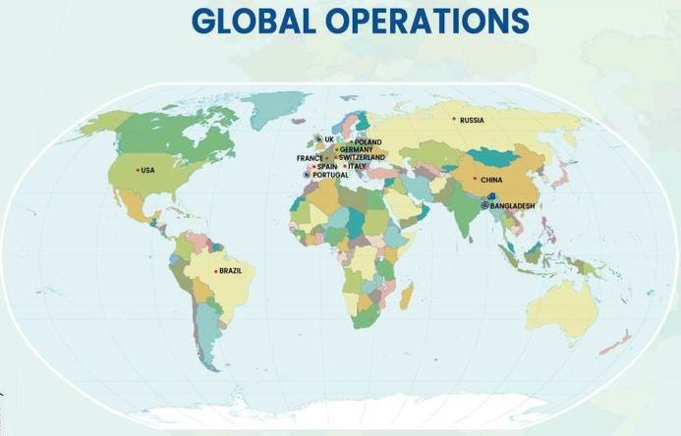

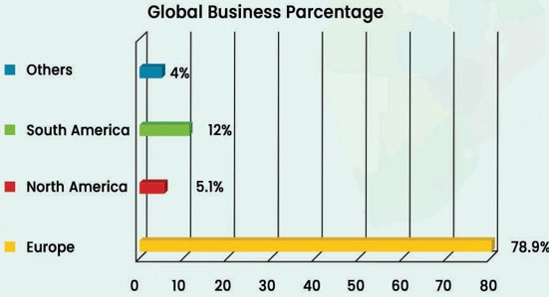
Showroom of REVERSE DESIGN

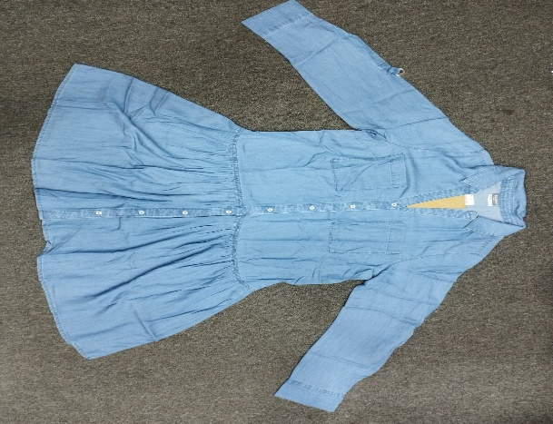
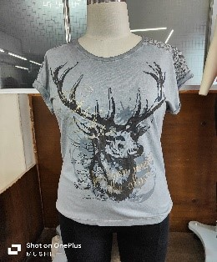
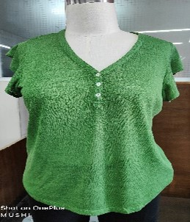
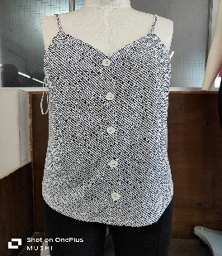
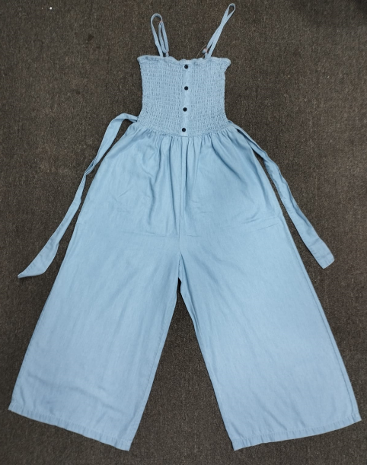
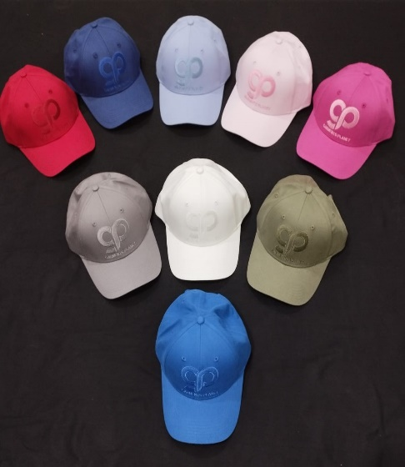
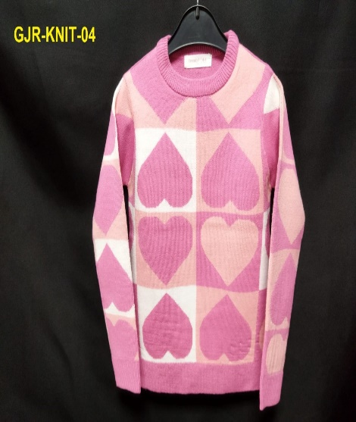
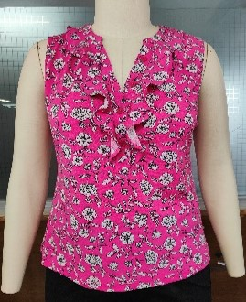
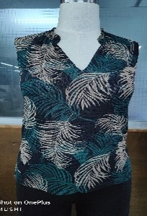
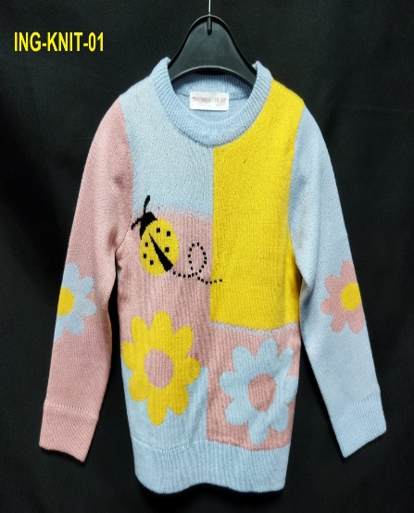
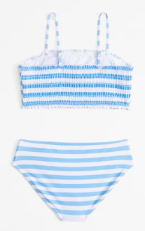
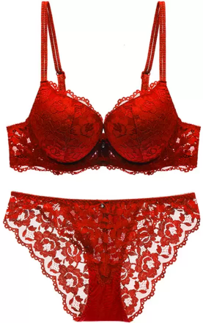
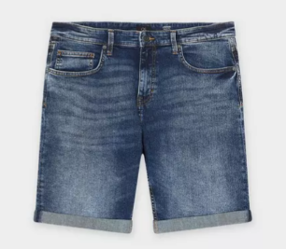
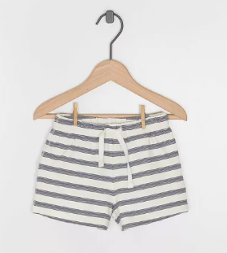
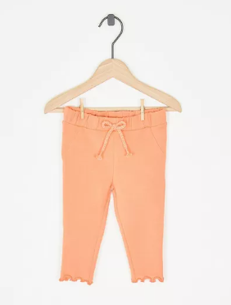
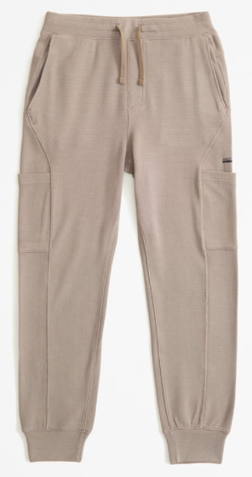
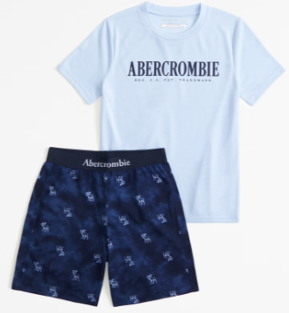
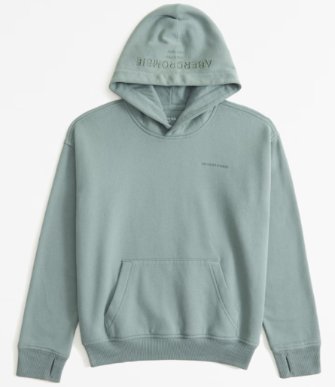
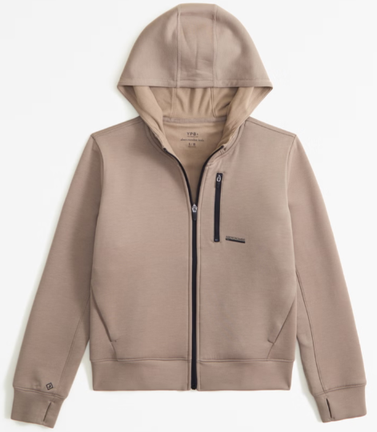
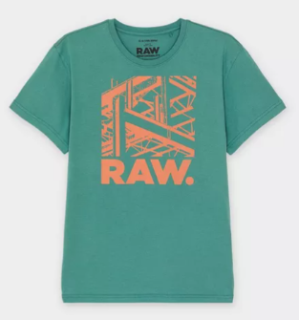
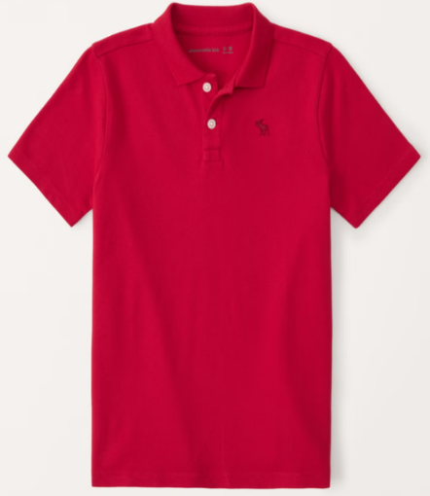
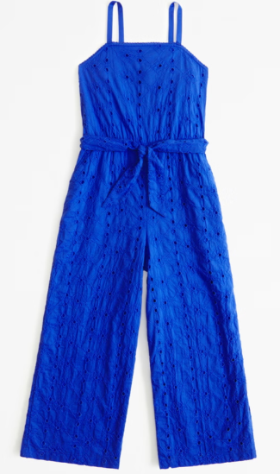
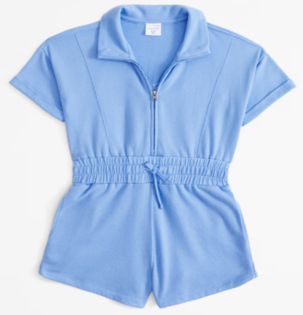
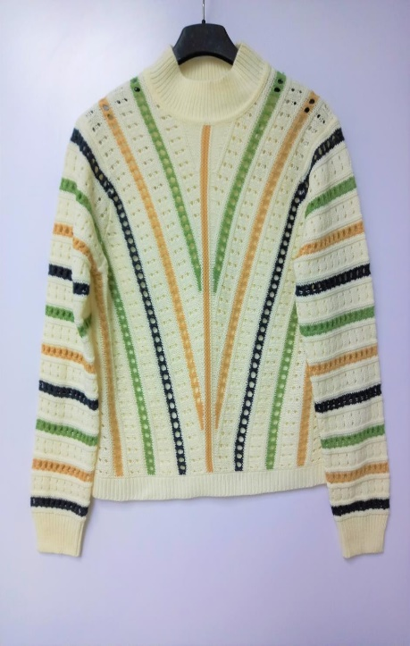
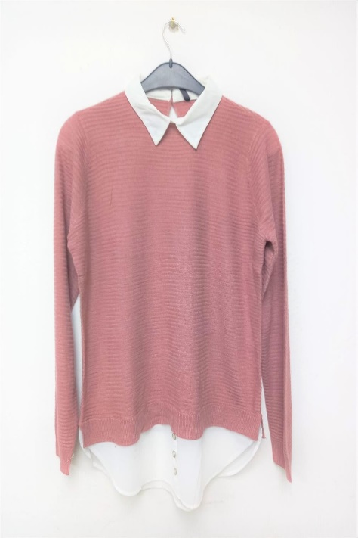
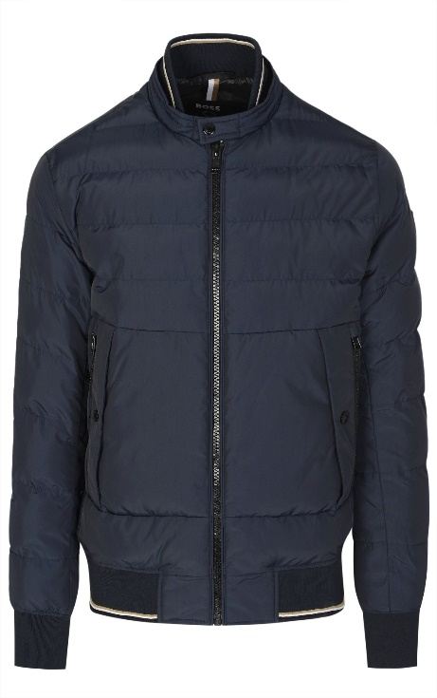
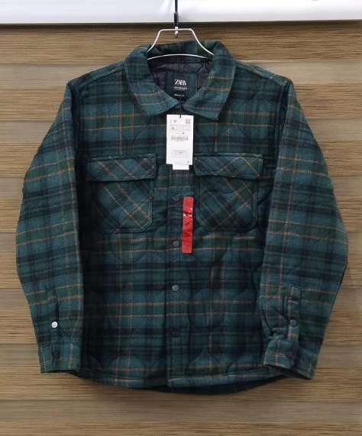
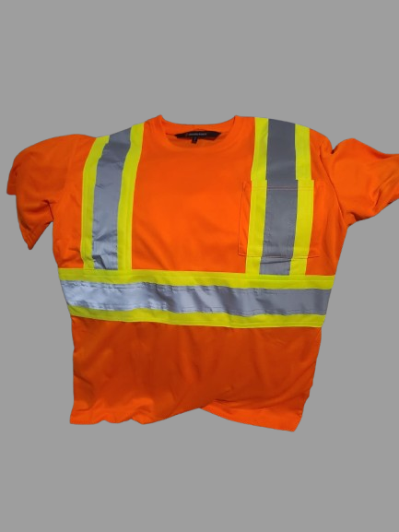
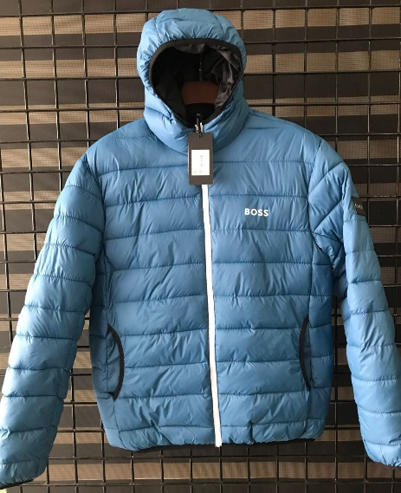
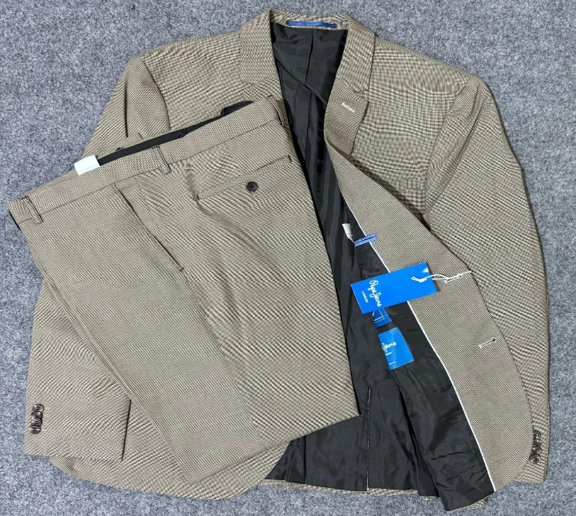
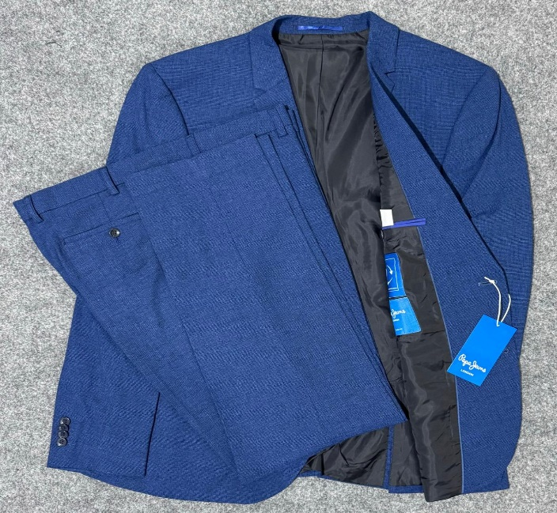
Summary

“We would like to start with you if you have any space for us, please feel free to share inquiry to proceed costing and development as well. After your feedback, in next mail we will send you our PPT for selected style for your easy work. Thanks, and positively looking forward to hearing from you. Our office is 15 minutes distance from the Int. Airport. So, you are cordially invited once visit in Bangladesh.”

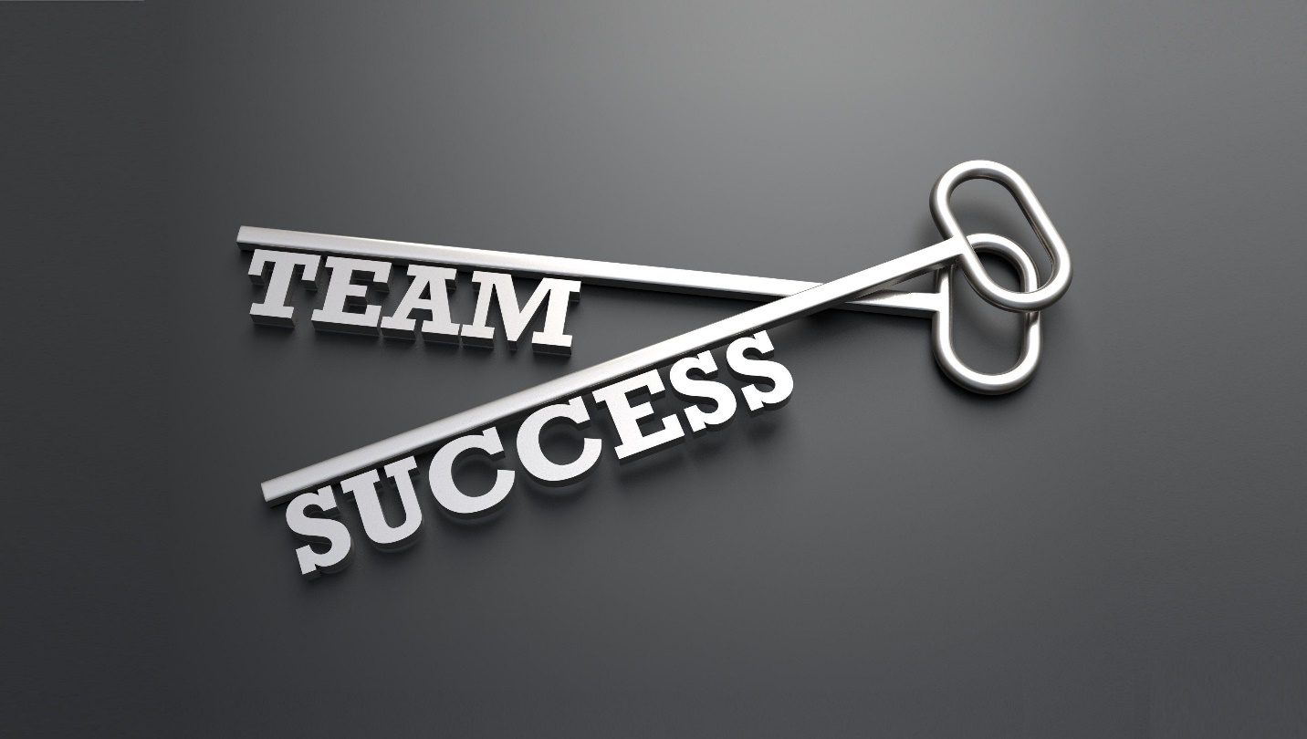

Thank you for reviewing our profile, if you find any mistake in this information or others, feel free to knock us for correction, we will be grateful to you.

Team
REVERSE DESIGN LTD.

THE END

